Comparability of Treatment: Where do we Stand?

Andrew Powell

The Center for Global Development and Williams College

March 2026

Acknowledgements: I would also like to thank Aitor Erce, Anna Gelpern, Starla Griffin, Nancy Lee, and other participants at the 8th DebtCon conference held at Georgetown Law School, Washington DC, October 14th 2025 for comments. I also wish to thank the Center for Global Development for supporting this work.
Introduction
Recent sovereign debt restructurings have proven to be complex and protracted. Inter-creditor issues, related to “Comparability of Treatment” (CoT), appear to be a main driver contributor to the delays. Considering 8 recent restructurings, the IMF estimates that, on average, they have each have taken over 2.5 years to complete.
The Paris Club (PC) introduced the concept of CoT to guard against the private sector “free riding” on official sector debt relief. The PC uses three indicators to judge if CoT has been met, allowing for tradeoffs and a degree of flexibility. But CoT has now become something of a mantra, used widely across different creditor groups, and each with its own preferred definition. This has led to calls for further reform and in parctuicular for a tighter definition of CoT. Some have gone as far as to suggest that CoT should only be measured according to present value reduction and with a single stipulated discount factor.
At first sight, this response seems logical. If different definitions of CoT were provoking problems in its application, then surely a stricter definition would help. An alternative view however is that the problems in applying CoT go deeper. Perhaps the problem is with the concept itself. Under this view, a tighter definition of CoT might actually provoke greater problems, not less. In this paper, I briefly review two particular issues with CoT which suggest further thought is required.
The first is that as noted debt comes in a very wide variety of forms. The plethora of instruments reflects different creditor preferences, and it follows that those creditors will also have different preferences on how they would wish those contracts to be restructured if required. Some creditors might prefer deeper present value reductions but maintain other elements of the contract, while others may wish to minimize the present value reduction above all other priorities. From the standpoint of the country, this means that a strict version of CoT, which focused only on a present-value criterion. Another way to say this is that the country would be able to obtain more debt reduction if debt instruments were valued taking into account all debt features and how creditor value those characteristics.
A second problem is that if it is widely known that a strict CoT rule will be applied in the case of a restructuring, then this will have implications for the debt structure ex ante. In particular, such a rule would sharpen the incentives for debt dilution. Those incentives arise when the value of existing debt is reduced if the country issues new debt. As a CoT rule makes it very clear that all debt will be reduced in comparable fashion in a restructurng then this will indeed give countries incentives to issue new debt. They will benefit from the proceeds of the new debt issuance, but the cost will be born, at least partially, by existing creditors rather than the issuer. This could then provoke greater incentives for countries to issue more risky short-term debt. In particular, it might exacerbate the problem of “gambling for resurrection” or in other words issuing more and more short-term debt, in an attempt to stave off a restructuring which would then be more painful if eventually required.
There seems to be a need to take a step back to understand the implications of CoT and attempt to understand if it is indeed the right concept. The idea of this paper is to prompt further debate on this question. As background, section 1 provides a brief account of the origins of CoT and recent discussions. In section 2, I discuss the issue of creditor preferences. I suggest that serious consideration should be given to employing mechanisms to elicit and harness information on those preferences rather than adopting a strict CoT definition that essetntially ignores them. One such mechanism would be a Product Mix Auction. This was designed precisely to reveal useful information and then find an efficient allocation across multiple related goods. A simple example is provided in an appendix to illustrate the PMA in action. Section 3 then considers the relation between CoT and the (ex ante) debt structure. A relatively simple model is developed to illustrate how the widespread adoption of a strict CoT rule might exacerbate the problem of debt dilution. Section 4 concludes.
- On the Origins of CoT and recent discussions
The Paris Club started to meet in the 1950’s to coordinate the rescheduling of official, bilateral, developing-country debt payments for countries facing payments’ difficulties. At this time, rescheduling meant pushing out maturities without nominal haircuts. Under the so-called Naples (December 1994) and Cologne terms (June 1999), some measure of nominal debt relief was approved for low-income countries eligible for IDA concessional loans, and for those that were eligible for the HIPC debt relief initiative, respectively. Initially, the CoT concept was used to compare bilateral official loans to bank loans, but that was then extended to incorporate bonds in 2020 as the developing country bond market expanded. The Evian terms, agreed in October 2003, cemented the possibility of bilateral debt relief for a wider set of countries, and the concept of CoT became further established, with the Paris Club stating that private creditors should give relief, comparable to that provided by bilateral creditors across different instruments.
The Paris Club indicates which variables it would consider, to determine if CoT has been met. These variables are a) the change in net present value (NPV), to capture the time value of the debt service payments before and after the restructuring, b) the change in duration before and after the treatment, where duration is measured as the weighted average time for all cash flows to be received and c) the change in nominal debt to be paid before and after the treatment. The Paris Club on its website provides further details on how CoT should be assessed.
The intention is not that every creditor should restructure debt in exactly the same way i.e.: comparable does not mean equal. Flexibility was advocated given creditors’ different preferences and to accommodate the use of different instruments. In particular, it was suggested that there might be certain tradeoffs. For example, one creditor might provide a smaller NPV reduction but a greater extension of duration, while other creditors might choose some other combination across the three dimensions mentioned, and this could still be considered as comparable.
- Creditor Preferences and CoT
Countries have many different types of creditors and debt instruments vary greatly. Instruments differ across many dimensions such as maturity, currency, fixed or floating rates, different amortization structures, whether they have embedded options, whether there are other contingencies or if payments are indexed to other variables (inflation, commodity prices, GDP). They also differ by the type of instrument including bonds issued in different jurisdictions, loans with an individual private party written under the law of different jurisdictions, syndicated loans or official (bilateral) loans. Some of these instruments are standardized, widely held among individual creditors and traded on liquid markets with transparent market prices, while at the other extreme some debt instruments are closely held and not traded. Others may lie between these extremes.
The variety of instruments reflects the different preferences of existing creditors. Creditors self-select into the instruments they prefer. Indeed, the observation that debt comes in many different types of contracts is evidence that preferences across creditors matter. Different creditors may have different valuations of the most salient aspects of each type of instrument. Creditor preferences may also vary considering holders of the same instrument. Where a market price exists for a particular instrument, that price reflects the average valuation across the individual creditors holding that instrument.
Suppose a country that has a wide variety of creditors and instruments must pursue a debt restructuring and let’s assume there is a strict version of CoT in force. If all creditors are forced to accept the same PV reduction of their debt valued at the same discount rate, this rule will only be efficient if all creditors agree on the discount rate and the only relevant difference in preferences across creditors is regarding the duration of that debt. Such a rule ignores any differences in how patient creditors are (which would impact the discount rate), their aversion to risk, their liking or disliking for different interest rate structures (floating vs fixed etc.), different currencies or any contingencies in the contract or any other relevant characteristics.
To put this in more theoretical terms, suppose a country issues a portfolio of debt contracts bought by a wide set of creditors that have different preferences over the monetary and non-monetary characteristics of those contracts. An optimal allocation would in general mean that the marginal utility of each creditor is equalized. Creditors would likely hold different amounts of debt, different portfolios of debt instruments with different prices for each dollar of debt raised (here I am assuming that each individual contract would have the same price to avoid arbitrage but different contracts would have different non-monetary characteristics valued differently by different creditors). Now suppose that the country has to restructure this debt. Imposing an equal present value reduction would in general be inefficient. The extent of this inefficiency would depend on how different creditor preferences are regarding the monetary and non-monetary characteristics of the contracts, and the nature of the interactions between the two. Only in very special cases, for example, where creditor discount rates were the same, where creditors were all risk neutral or had the same degree of risk aversion and where the utility of the monetary and the non-monetary contract characteristics were separable, might imposing equal present value haircuts with a specified discount factor be efficient.
In general, a restructuring that ignores the potentially wide variety of creditor preferences is likely to be inefficient. Another way to state this is to say that by choosing only one level of debt reduction that is acceptable to all, the country would very likely be leaving money on the table. Suppose a strict definition of comparable treatment is in force, then to ensure a successful restructuring, the country may have to choose a relatively low amount of PV debt reduction, ignoring the possibility that some creditors would have accepted a deeper discount, if offered instruments with elements that added value for them. Or, equally, for the same degree of debt reduction, creditors could be made better off (in terms of utility) by taking their preferences into account.
However, while creditors may have varied preferences across different dimensions and hence prefer different debt instruments, in general those preferences are not observed. While creditors may sort into the instruments they prefer, and some of those instruments may have market prices per unit of debt, this only provides partial information at best. As mentioned, even creditors holding the same instrument may have different preferences and a market price then only reveals a type of average valuation. What is needed is then a methodology that elicits information on preferences and harnesses that information to ensure an efficient debt restructuring.
This is precisely what auction mechanisms are designed to do. The auction mechanism is designed to reveal how much value bidders place on the good(s) on sale and to provide a way to efficiently allocate those goods across buyers. In the case of a debt restructuring a borrowing country can be thought of as the seller, of a set of new debt contracts to replace the existing ones, and the creditors can be thought of as the buyers that bid for those new debt contracts. A complication however is that while many auctions are designed to sell a single good, here a set of closely related “goods” (the various new debt contracts) would be up for sale. Luckily, methodologies have been developed for precisely this type of problem and are already in use in other applications.
An auction mechanism known as the Product Mix Auction (PMA), has been developed by British Economist, Paul Klemperer (see Klemperer in (2006), (2010) and (2018)) and Willems (2020 and 2021) proposes the use of the PMA for debt restructurings. The idea of the PMA is to use a single set of simultaneous relative bids for a set of related “products” to elicit information about creditors’ valuations (preferences) across those different instruments in relation to a numeraire - such as a standard (plain vanilla) bond. This mechanism then exploits the differences in preferences between creditors rather than seeing that variation of preferences as a hindrance. A language of bids could be developed which would allow creditors to express their preferences across instruments of different maturities, currencies, whether fixed or floating, and across alternative contingent features. Each creditor may make multiple bids. A set of relatively simple bids then allows each creditor to express quite complex preferences across a variety of instruments in a relatively simple fashion.
It is worth noting that this idea is not just an academic proposal, the PMA is in actual practical use. For example, a PMA auction is used by the Bank of England to auction liquidity provision to banks in the form of long-term repos backed by alternative collateral. Please refer to Klemperer (2018) and Bank of England (2019) to read about this and other applications.
Applying this technique to a debt restructuring, the basic idea would be to use the bids of creditors, for instruments to replace existing debt contracts, to develop functions analogous to demand curves for the instruments. Each creditor would have a budget constraint determined by the volume of debt that that creditor had outstanding. The demand functions would then indicate how much of the initial budget would flow into each new debt instrument. This then provides the demand side.
The Product Mix Auction (PMA)
The objective of the PMA is an auction process to sell a variety of goods that are close substitutes in a single auction. The Bank of England asked Paul Klemperer to design such a mechanism to auction repo contracts with different collateral quality to provide liquidity to banks – see Klemperer (2009. 2010 and 2018). Willems (2020, and 2021) discuss how this technique can be adapted to the context of a sovereign debt restructuring or a debt swap/liquidity management operation.
In the PMA, buyers may make several bids which express preferences between different options – the close substitute goods. In the context of a sovereign debt restructuring these could be preferences between various instruments, that the country offers to replace existing debt, versus a standard bond which could be considered as the numeraire. Bidders can submit multiple bids expressing preferences across different instruments offered and which could vary in quantities.
An important question for the seller – the country debt restructurer – is which instruments to offer, the selection of instruments should span the different features of debt contracts that might appeal to different creditors. These multiple, relative bids then allow the seller to construct functions analogous to demand curves for each of the instruments offered.
The country should communicate to creditors the buyers, the new target aggregate debt profile and amortization schedule. Ideally there would have been agreement on an aggregate target debt structure informed by a debt sustainability analysis, perhaps conducted by the IMF or other reputable institution. This is important for the auction process as creditors may need to have this information to be able to value new instruments correctly.
Armed with the “demand curves” for the different varieties of debt, the budget constraint for each buyer (which might be the face value of each buyer’s claim), and the target aggregate debt profile, then using the PMA algorithm the country can allocate quantities of the new instruments to each creditor. Each creditor would obtains each type of net debt at a common price. In principle ,many different varieties of debt contract could be included in the auction.
The mechanism assumes that creditors bid truthfully according to their preferences and if they do the resulting allocation will be efficient in the sense that it would mirror an efficient market. Each creditor would prefer the allocation received compared to the allocation obtained by any other creditor. There is a potential danger if there are large creditors that might be able to manipulate the process, this would have to be monitored carefully. Please see Appendix 1 for a simple example of the PMA in action.

A prior debt sustainability analysis (DSA) would indicate the maximum volume of debt that the country could carry going forward, and details of the new planned amortization profile. In the extreme, the country could specify the new aggregate quantity of each type of debt. This would then pin down the supply side as a specific point. An alternative would be to specify certain key aspects of the new debt structure but allow some flexibility to decide quantities, dependent on the bids.
There is a subtle issue here as the valuation of some types of debt may depend on the quantities issued of other debt types. For example, long-term debt might be valued more if there is less short-term debt present. The information that the country would provide to creditors over the new debt structure is then something to consider quite carefully.
An algorithm then considers the individual bids across all the creditors for the different types of debt that are on offer and with that information plus the target new aggregate debt profile calculates an efficient allocation of the new debt across creditors, which would satisfy the sustainability constraint. An appealing feature of the mechanism is that assuming that creditors bid truthfully then the result should be one of “no regret”. In other words, a creditor should not receive an allocation across the different instruments that did not accord with that creditor’s preferences. Appendix 1 details a simple example of the PMA in action, contemplating a debt restructuring with 3 maturities of debt.
The first priority of the country will be to ensure success in the auction in the sense that the resulting total aggregate debt satisfies its sustainability thresholds. However, within that broad objective the country may be able to choose the a debt composition that it finds preferable. For example, the country may prefer to offer instruments that hedge risks and limit those that it might consider would make the debt structure risky. Within the context of the PMA, the country could choose relative prices depending on the bids received. In the case of the Bank of England’s (BoE) PMA auction, the BoE provides liquidity to commercial banks on the basis of stronger and weaker collateral but in general prefers to extend only a limited amount on the basis of weak collateral. There are then techniques within the context of the PMA to improve debt structures.
Another advantage of the PMA is that it yields a tremendous amount of information. Countries are often poorly informed regarding the preferences of the various creditors. Given the competition and rivalry between creditors they are loathe to reveal information to the country. By the same token the country in general will prefer not to reveal too much information to creditors. Providing certain conditions are met it is normally in the interests of creditors to make bids in accordance with their preferences. In general, it may also be in the interests of the country to reveal the nature of its preferences regarding the aggregate debt structure. The mechanism then provides a framework to generate information which should make a settlement easier (and faster) to achieve.
The PMA mechanism provides an interesting alternative to the current thrust towards a strict definition of Comparability of Treatment. If creditors exhibit a variety of preferences, a restructuring subject to a strict CoT rule will be inefficient. By contrast, the PMA mechanism has the potential to elicit information on those preferences and deliver a swift and efficient restructuring. A second issue relates to the impact that such a rule might have on ex ante debt structure. This is the topic of the following section.
- Comparable Treatment and Implications for debt structure
Expectations regarding how debt will be restructured will impact debt levels and debt structure before a restructuring takes place. The ex ante impacts of alternative debt restructuring rules have not received a great deal of attention in the discussion on the debt restructuring framework to date. However, given the discussion regarding adopting a strict CoT rule, this seems highly appropriate.
While there has been little discussion in policy circles on the topic, several academic papers have focused on how countries choose debt structure. In particular, debt dilution has been identified as a serious issue. If a country has debt outstanding, there is a probability that that debt will be restructured and if the payments to existing creditors are reduced given greater quantities of debt being issued, then there may well be incentives for a country to issue new debt. The key insight is that, while the country may enjoy the full proceeds of the new debt issuance, part of the costs will be borne by existing creditors who will get lower payments if the debt is restructured - their debt is diluted. However, whether these incentives are there or not depends critically on the expectation of how debt will be treated in a restructuring.
Hacthondo et al (2016) develops a dynamic model of sovereign debt. Their model assumes that there is legacy long-term debt and there is some probability of default. In their analysis, there is a strong incentive for the country to issue new debt and dilute existing creditors. In standard dynamic models of sovereign debt, it has been hard to justify the high debt ratios found in many economies. Hatchondo et al (2016) argues that debt dilution may explain a significant part of those ratios.

At the same time, a number of papers have argued that there would be an advantage to there being some type of seniority structure in sovereign debt. Gelpern (2004) and Bolton and Skeel (2004) both argue in favor of a seniority structure. The main role of such a structure is to counter the problem of debt dilution. Chatterjee and Eyigungor (2015) provides a theoretical model, and concludes that a modified “absolute priority” or “first-in-time” rule (such that creditors who lend first are paid first) may result in less dilution and ex ante benefits for borrowers.

To my knowledge, no paper to date relates the issue of debt dilution to the topic of Comparability of Treatment, and in particular to the thrust of the current discussions towards a strict definition of CoT. In this paper, I provide a simple theoretical model to illustrate the point. The technicalities of the model are detailed in the Appendix to the paper, here I discuss the model set up, the results and their implications.
The model set up
The model employs a simple sovereign debt framework. I assume a country issues one unit of debt to invest in a project which pays an uncertain return (y). I will refer to this debt as type A debt. The idea is that if the project is successful and pays a high rate of return (yH), then the debt will be repaid with interest. However, if the project pays only a low return (yL) the country may choose to default and restructure the debt. I assume the probability of yL is p and of yH is (1-p) and that the country wishes to maximize its expected net return which it can then consume (i.e.: the country is risk neutral).
We are in the world of sovereign debt and so there is no enforcement regime to ensure repayment. It is assumed that if there is a default, then the debt will be restructured in such a way that creditors receive a fraction of the value of the project – lets call this λy where λ (the Greek letter lambda) is between 0 and 1. This can be thought of as what the creditors can extract from the borrower, or what the borrower can afford to repay. As the creditors receive a fraction of the value of the return of the project on restructuring the debt, it follows that restructuring will indeed occur when the project return is low. It is also assumed that there is an additional deadweight cost that the country has to pay if there is a default and a debt restructuring – I refer to this as phi (Φ).
The timing of the model is that first the country issues one unit of A debt. At the end of the period, it receives the return on the project and decides whether to repay the debt. The country can then consume the net returns after it has repaid the debt or paid the fraction of the project value and deadweight cost in the case of a restructuring.
We assume that creditors are risk neutral and competitive which implies that the overall expected return to investors in the type A debt should be equal to the “risk free rate” (r), which represents the opportunity cost of investing in this risky debt, rather than investing in a risk-free asset. If there is no default the A creditors receive the face value of the debt plus interest and if there is a default and restructuring, they will receive λy which will be less than the debt plus interest due. This implies that the interest rate should be higher than the risk free rate (rA>r) to compensate for the risk. So far this is a simplified standard sovereign debt framework. It is easy to solve for the interest rate rA and the country welfare – see the Appendix.
The model with two types of debt and strict comparability of treatment
Now let’s complicate the model. Let us suppose that after issuing one unit of type A debt, the country can issue more debt, let’s call it type B debt. This debt has no purpose per se, no additional investment conducted. The country can invest the proceeds in a risk-free asset and get those returns at the end of the period. However, the country now has more debt that it will need to repay. And if there is a chance of default, then the B creditors will need to be compensated for the risk they are taking with an interest rate higher than the riskless rate. At first sight it may seem strange that the country may wish to issue this new type of debt as it serves no real purpose.
Whether the country does, or does not wish to issue this new debt, depends critically on what happens if there is a default. Let’s first assume that the two types of debt are treated strictly comparably. This is interpreted as the following a) if there is a default on type A debt then there would also be a default on type B debt and vice versa and b) on default and restructuring, each creditor, whether of type A or type B debt, should receive the same payment per unit of debt. In this simple case strict comparable treatment is essentially the same as saying the debt is treated pari passu.
Consider what happens after the country first issues one unit of A debt, lets say at an interest rate rA. It now has to decide whether to issue B debt. If it issues B debt at any interest rate above the riskless rate and then repays both the A debt and B debt, then it has lost out. However, if it issues B debt and then defaults it may gain. To see this note that the country pays only a fraction of the value of the project in default (λy) irrespective of how much debt it issues. So, if the country issues B debt and then defaults, it can enjoy the proceeds of that debt issuance (invested at the riskless rate) but there is no additional cost to the country. The losers in this case are the A creditors. As the A and the B creditors are treated comparably, the A creditors will get a smaller part of the total payment to creditors (λy), the greater the volume of B debt that is issued. The A debt is diluted.
This argument illustrates the problem of debt dilution. If there is debt outstanding, there is a probability of default, and the payments to the first group of creditors in default depend on the volume of the new debt issued, then in general there will be an incentive for the country to issue more debt. If there is a rule that all creditors will be treated strictly comparably in a debt restructuring, then this makes clear that the existing creditors will indeed receive lower payments if more debt is issued. A strict comparability of treatment makes the incentives for dilution abundantly clear.
If the country has the possibility of issuing new debt (the B debt) it is important to consider what the original creditors (investors in the A debt) believe is going to happen. Will the A creditors anticipate the dilution or not? Suppose they did not, and the dilution came as a surprise. In that case they would be willing to lend at the same interest rate as before (when the country had no possibility of issuing new debt). But then if the country did issue B debt, that interest rate would be “too low”, it would not reflect the actual expected return (once the B debt had been issued). This would not constitute a dynamic equilibrium as normally defined in economic theory. The A creditors would regret having lent at the relatively low interest rate reflecting a safer investment.
An alternative is to posit that the A lenders anticipate the dilution. In this case they will demand a higher interest rate. Let’s assume they know exactly the parameters of the model and they will how much B debt will be issued. In this case, if the two types of debt are treated comparably, the A creditors would charge the same interest rate that the B creditors would also demand as the probability of default and the payment per unit of debt, if there was a restructuring, would be the same.
It is important to remember the timing of the model. The country first issues the A debt, but now at a higher interest rate. After that, the country must decide whether to issue the B debt or not. It turns out that in general the country will have the incentive to issue the maximum amount of B debt that is feasible.
The parameters used in the model are set such that when there is no B debt (or when B takes a low value), the country will default when the project return is low (y=yL) and the country will repay if the project is successful (y=yH). But what happens when B rises? If B becomes very large, then the country may also choose to default at yH. The maximum feasible B debt issuance is such that the country just prefers to repay at yH. This is known as a boundary condition and defines how much B debt will be issued when the country has incentives to dilute (see the Appendix for more details). Given B debt issuance it is then possible to solve for rA and rB (which are equal) and then for country welfare. The interest rate, rA, is higher when debt is diluted in this fashion compared to the case where B=0.
The possibility of issuing B debt represents a time consistency problem. Once the A debt is issued and rA determined, the country has an incentive to issue B debt when there is strict comparability of treatment. The reduction in welfare is the cost of not being able to commit to not issuing this additional debt. In this simple model that cost is just p*Φ (the probability of default * the additional deadweight cost). Now, a strict CoT rule would make the incentives for debt dilution very transparent.
Alternative debt restructuring rules
What happens under alternative debt restructuring rules? An opposite extreme to strict comparability would be to make the A creditors strictly senior. A strict seniority rule would say that in the case of a default and debt restructuring, the A creditors would get paid first until they are paid the total they are owed (if that is feasible) and only if there are resources left over would the B creditors receive any payments. Under such a rule, the existence of the B debt does not impact the A creditors at all. The incentive for dilution then disappears. Strict seniority would resolve the debt dilution problem in this model.
But strict seniority is not actually necessary to eliminate the incentives for dilution. Consider a mixed rule where some fraction alpha (α) of the A debt is considered senior and the remaining fraction (1-α) is treated as strictly comparable to the B debt. Depending on the parameters as α is increased from zero, at some point the incentive for dilution may disappear. This occurs when the resources available to pay the B creditors in default dwindle to zero, which is when $λ*yL-α*rA$ = 0, as α*rA is what is paid to the senior part of the type A debt and λ*yL are the resources available to pay creditors in default (see the Appendix for more details).
Consider a numerical example to see this model in action. Assume yL=1, yH=4, p=0.1 (the probability of the low state which is also the probability of default), r=1.05, λ=0.5 and ∅=0.2. The project is highly profitable in the sense that the expected return is much greater than the riskless rate of interest, the default probability is 10% and on default creditors can extract 50% of the project return and there is a deadweight cost of 0.2 which doubles to 0.4 if there is both type A and type B debt. Under these parameter values in the model with strict comparability of treatment (α =0), there would be an incentive for the country to issue B debt to the maximum feasible amount which would be 1.1 units of debt. This is illustrated in Figure 1 below.

Figure 1: Issuance of B debt versus the degree of A debt seniority (alpha)
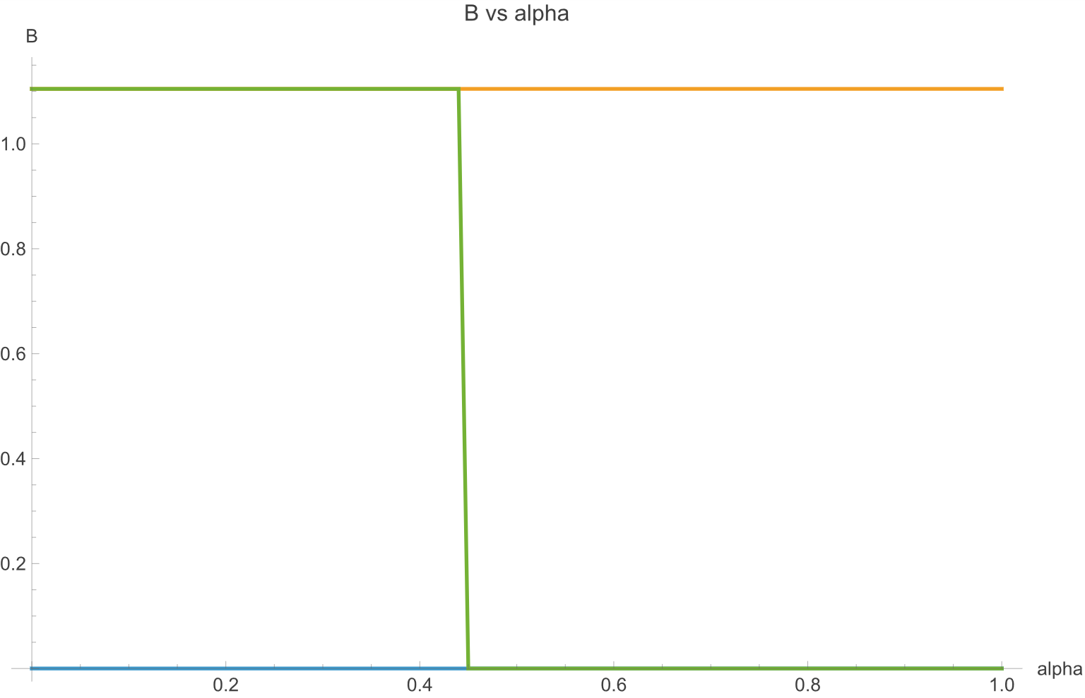
As α increases, B does not change as actually the boundary condition for B does not change. The interest rate on B debt increases with α, as more resources in default are directed to pay the larger senior A debt tranche, and less resources are available to pay the B creditors. The increase in rB is illustrated in Figure 2.
Figure 2 The interest rate on B debt (rB) versus A debt seniority of A (alpha)

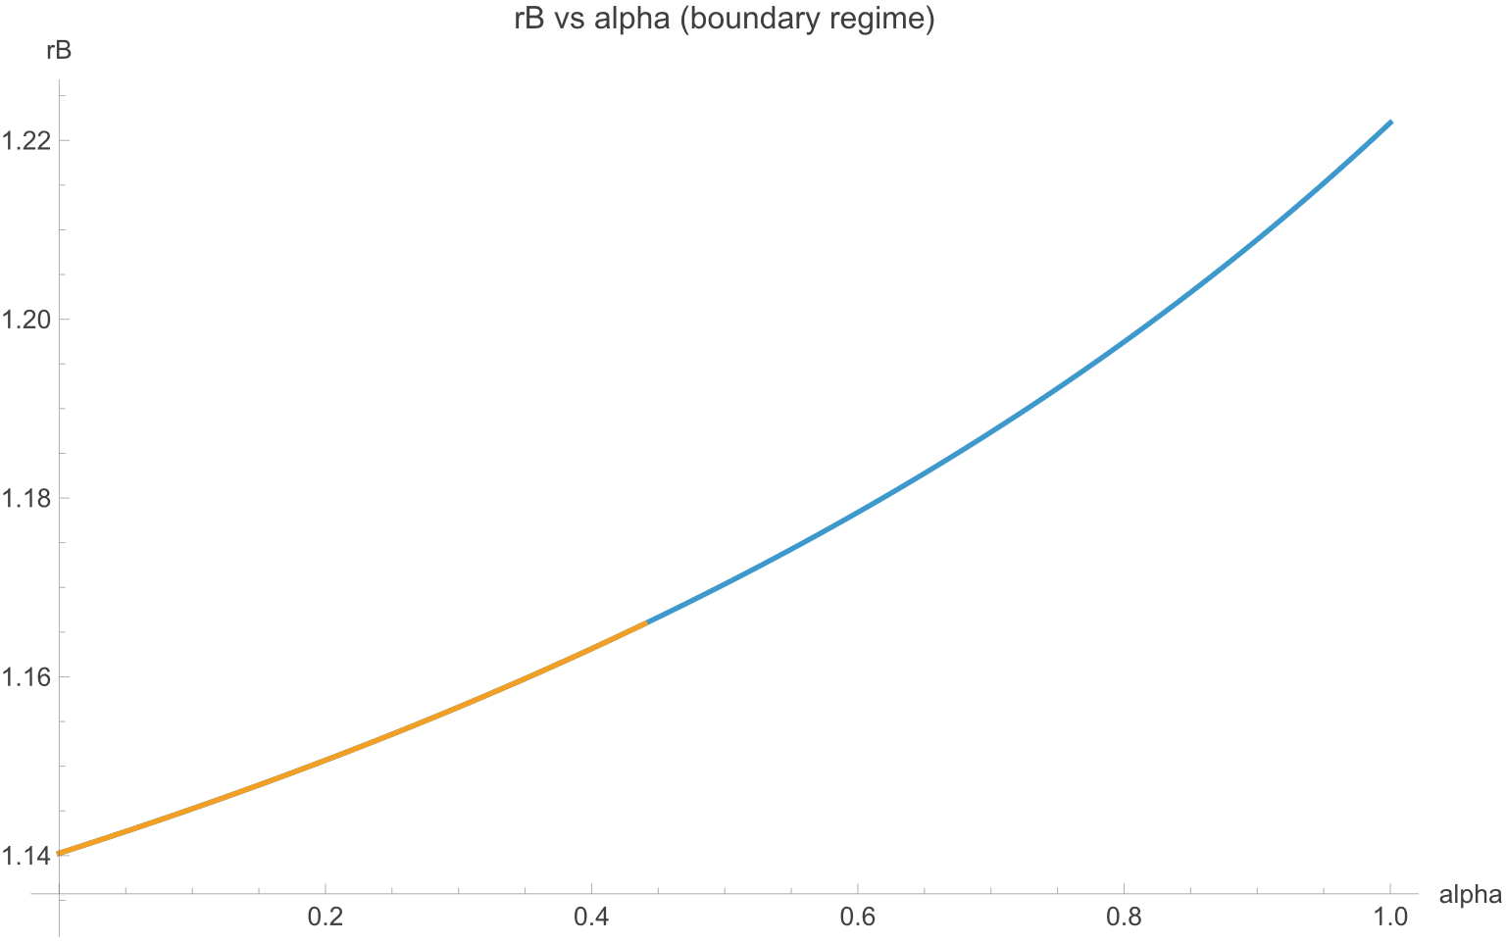

However, in this example when α=0.45, the incentive for dilution is eliminated. At that point the country chooses not to issue B debt at all. The selected equilibrium then shifts to zero B debt. This is depicted in Figure 1 as the green line, which dips to zero at that point. If B had continued to be issued to the maximum feasible amount, then rB would continue to increase as shown in Figure 2, but this is irrelevant as the selected equilibrium is with B=0. The A creditors would anticipate that B would now be zero and the model would revert to the simpler case with only A debt as described above. As B debt falls to zero, country welfare jumps higher at this level of α. The Appendix contains graphs for the interest rA and for country welfare given this numerical example. In our example country expected net income (the same as welfare) would be 2.61 in the equilibrium with debt dilution (low α) and 2.63 in the equilibrium when B=0 (α>0.45). As discussed, the difference can be interpreted as the welfare cost of the country not being able to commit not to issue new debt.
This simple model illustrates how ex post restructuring rules can influence the amount of debt a country would wish to issue and the cost of that debt. In particular, it indicates that a strict comparable treatment rule across different creditor groups might exacerbate the problem of debt dilution, increase debt levels and lower country welfare.
Conclusion
In this paper, I have raised two particular issues with a strict definition of Comparability of Treatment (CoT). First the plethora of different debt contracts suggests that creditor preferences vary widely. Creditors sort into the debt contracts that have monetary and non-monetary features that they find attractive. A debt restructuring that insists on a common reduction in present value, especially using a single specified discount rate, may be highly inefficient. It would leave money on the table in the sense that the country could be able to obtain greater debt reduction and leave creditors just as well of, or make creditors better off while obtaining a similar amount of debt reduction in present value terms.
In contrast, adapting the Product Mix Auction (PMA) to the context of debt restructuring would allow creditors to express their preferences across instruments, and use that information find an efficient allocation. A nice property of the technique is that the resulting allocation should have a “no regret” policy or in other words, given the final set of instruments and prices that are available, each creditor should have the allocation that that creditor would prefer. In addition, the mechanism could elicit valuable information on innovative contracts, allowing the borrower to judge which contracts might be most valuable to include. The PMA is a simultaneous multi-product auction which could speed up restructuring processes and applied in a way that would ensure that the aggregate new debt profile complied with a debt sustainability constraint.
A second issue with doubling down on a strict version of CoT is that if it is widely known that all debt would be treated equally in a restructuring, then this could have deleterious consequences for debt structures ex ante. CoT would sharpen incentives for countries to dilute existing debt, raising debt ratios and increasing interest rates. This might increase the incentive to gamble for resurrection, where the country issues more and more short term debt, in the attempt to stave off a restructuring, which would then make the restructuring (even) more costly.
In contrast, a rule which gives some seniority to existing debt reduces the dilution problem. A problem with the idea of a seniority structure is that there is no obvious way to enforce any seniority rule. The same problem exists with regards to a strict-CoT rule, as recent discussions have highlighted. Any efforts to enhance strict-CoT would be better directed in enforcing a rule that would diminish the problem of debt dilution, rather than cementing it within the international financial architecture. Greater thought should be given on how to combine techniques that elicit information on creditor preferences and diminish debt dilution incentives.
References
Anderson, R., W., C. Gilbert, and A. Powell (1989) “Securitization and Commodity Contingency in International Lending”, American Journal of Agricultural Economics, May 1989, Vol. 71, pp. 523-30.
Arellano, Cristina. (2008) “Default Risk and Income Fluctuations in Emerging Economies.” American Economic Review, 98 (3): 690-712.
Bank of England (2019) “Indexed Long-Term Repo Process Guide Sterling Monetary Framework” Bank of England Website, Updated 2019
Bolton, Patrick and Olivier Jeanne (2009) “Structuring and Restructuring Sovereign Debt: The role of seniority” Review of Economic Studies 76 (3): 879–902.
Bolton, Patrick and David Skeel (2004) “Inside the Black Box: How Should Sovereign Bankruptcy Framework Be Structured?” Emory Law Journal 53: 763–822.

Chatterjee, Satyajit and Burcu Eyigungor (2015) A Seniority Arrangement for Sovereign Debt American Economic Review 2015, 105(12): 3740–3765
Cordella, Tito and Andrew Powell (2021) “Preferred and Non Preferred Creditors” Journal of International Economics, Volume 132, September 2021,
Gelpern, Anna (2004) “Building a Better Seating Chart for Sovereign Restructurings.” Emory Law Journal 53: 1119–61.

Georgieva, Kristalina and Ceyla Pazarbasioglu (2021) “The G20 Common Framework for Debt Treatments Must Be Stepped Up” IMF Blog, Dec. 2021.
Hagan, Sean and Brad Setser (2024) “Restructuring sovereign debt: The need for a coordinated framework” Peterson Institute for International Economics, Policy Brief 24-4, May 2024
Hatchondo, Juan C., Leonardo Martinez, and César Sosa-Padilla (2016) “Debt Dilution and
Sovereign Default Risk.” Journal of Political Economy, Volume 124, Number 5, October 2016

IMF (2025a) “Global Sovereign Debt Roundtable Compendium of GSDR Common Understanding on Technical Issues” IMF Website

IMF (2025b) “A Stocktaking of the current international architecture for resolving debt involving private creditors” October 2025.

Klemperer, P (2009), “Central Bank Liquidity and “Toxic Asset” Auctions”, VoxEU.org, 25 September.

Klemperer, P (2010), “The Product-Mix Auction: A New Auction Design for Differentiated Goods”, Journal of the European Economic Association 8: 526-36.

Klemperer, Paul (2018), “Product-Mix Auctions”, Nuffield College Working Paper, University of Oxford.

Landers, Clemence and Rakan Aboneaaj (2023) “Should MDBs Be Leading the Adoption of Debt Pause Clauses?” Center for Global Development Blog Post, April 13, 2023.

Lazard (2022) How to Make Sovereign Debt Restructurings More Effective: Hold Warring Parties to a Better Standard of “Comparability”, Mimeo, May 2022

Makoff, Gregory (2024) “Default: The Landmark Court Battle over Argentina's $100 Billion Debt Restructuring” Georgetown University Press, February 1st, 2024.

Panizza, Ugo “The Pitfalls of Value Recovery Instruments in Sovereign Debt Restructuring” Finance for Development Lab (6 September 2024) https://findevlab.org/the-pitfalls-of-value-recovery-instruments-in-sovereign-debt-restructuring/ accessed 20 September 2024.
Paris Club (2024) “What are the main principles underlying Paris Club work?” Paris Club Website https://clubdeparis.org/en/communications/page/what-are-the-main-principles-underlying-paris-club-work
Reichert-Facilides, Daniel “Enforcing Comparability of Treatment – Why, what, how, where? And which Remedies?” mimeo
Rivetti, Diego (2022) Achieving Comparability of Treatment under the G20’s Common Framework, Mimeo, World Bank, Equitable Growth, Finance and Institutions Note.
Schlegl, Matthias, Christoph Trebesch and Mark L.J. Wright (2019) The Seniority Structure of Sovereign Debt, Working Paper 25793 http://www.nber.org/papers/w25793 NBER, Cambridge, MA 02138 May 2019
Weidemaier Mark, Ugo Panizza and Mitu Gulati (2022) “FUD and the Ghana 2030 Bond” Financial Times AlphaVille November 29 2022.
Willems. Tim, (2020) “A proposal for an auction-based sovereign debt restructuring mechanism” VoxEu November 2020.
Willems. Tim (2021) “An Auction-Based Sovereign Debt Restructuring Mechanism” IMF Connect, IMF, March 202.
Weiss, Martin A. “The Paris Club and International Debt Relief” Congressional Research Office, Dec. 2013.

Appendix 1. The Product-Mix Auction in Action
Introduction
Consider a sovereign with debt of 120 units. Suppose that there are three types of debt, which we will label short-term debt (S) of 60 units, medium-term debt (M) of 40 units and long-term debt (L) of 20 units. For simplicity, assume that all debt is zero coupon. A debt sustainability analysis (DSA) indicates that the sovereign cannot service its debts and that it should restructure. Suppose the DSA suggests that debt should be at most 80 units, which again we will assume is all zero coupon, and amortization payments can amount to at most,
$$Q_{S}=30,Q_{M}=30,Q_{L}=20.$$
where Q_{i} is the amount of debt of category (Short, Medium and Long). This implies that the country must seek an aggregate nominal haircut of 33.3% in the restructuring. In this example, we will then assume that this new debt structure is given and so the role of the PMA is to determine the allocation of the new debt instruments across creditors. More generally, the PMA could be used to obtain valuable information on whether to introduce new types of debt contracts. However, as discussed in the text, it may be important to inform creditors, at least in broad terms, what the new aggregate debt structure will look like, as creditor valuations (and hence bids) for a specific type of debt, may vary depending on that structure. For example, creditors will likely value longer term debt less if there is a greater quantity of short-term debt.

The Auction-entry instrument and budgets
As proposed by Willem (202x), to make the auction uniformly applicable across the legacy bonds, all the old claims are first exchanged 1:1 into an auction-entry instrument. Each creditor will then enter the auction with a budget equal to the principal of its legacy claim in this instrument. Let’s assume that there are six creditors and their initial budgets are as depicted in Table A1.1.
Table A1.1: Creditor Budgets $B_{i}$
Creditor  C1 | Budget  30
C2 | 25
C3 | 20
C4 | 18
C5 | 15
C6 | 12
Note that these budgets sum to 120, the face value of the legacy debt stock.
The bidding language and the numeraire
We define the Short-term debt $S$ as the numéraire. Creditors are then asked to make bids. They may make multiple bids for different tranches of their initial budgets. A bid for a particular tranche is written as, $\left(100S, x_{M}M, x_{L}L\right).$This means the following, “For this tranche,, I am indifferent between being compensated with 100 units of short-term debt, $x_{M}$units of medium-term debt, or $x_{L}$units of long-term debt.” Thus $x_{M}$and $x_{L}$are relative bids expressed in units of the numéraire. A lower $x_{M}$means the creditor is more willing to accept medium-term debt; a lower $x_{L}$means the creditor is more willing to accept long-term debt. If all creditors prefer shorter maturities, then it would be expected that creditors bid such that,
$$x_{L}>x_{M}>100.$$However, the strength of creditors’ dislike for longer term debt may be quite different across creditors. A creditor that strongly dislikes long term debt will ask for many more long-term bonds for each unit of short-term debt, compared to a creditor that prefers short term only marginally over long term debt. Again, this is a simple example to show the PMA in action. The only difference between creditors is over their relative dislike for longer term debt. More generally, there could be different amortization structures, floating vs fixed, different currencies, contingency arrangements etc. Here the example is kept simple to focus on the mechanism at work.

Example Bids
Each creditor may make multiple bids by splitting their initial budget into a number of tranches. Table A1.2 provides a set of bids to show what they might look like.

Table A1.2. Tranche bids in units of short debt
Creditor | i Tranche | Budget share $b_{ij}$ | $100S$or $x_{M}M$or $x_{L}L$
C1 | T1 | 10 | $100S$or $120M$or $155L$
C1 | T2 | 10 | $100S$or $135M$or $220L$
C1 | T3 | 10 | $100S$or $170M$or $260L$
C2 | T1 | 3 | $100S$or $128M$or $165L$
C2 | T2 | 10 | $100S$or $140M$or $225L$
C2 | T3 | 12 | $100S$or $178M$or $270L$
C3 | T1 | 8 | $100S$or $145M$or $230L$
C3 | T2 | 12 | $100S$or $185M$or $280L$
C4 | T1 | 6 | $100S$or $132M$or $172L$
C4 | T2 | 2 | $100S$or $148M$or $235L$
C4 | T3 | 10 | $100S$or $190M$or $285L$
C5 | T1 | 4 | $100S$or $150M$or $240L$
C5 | T2 | 11 | $100S$or $195M$or $290L$
C6 | T1 | 1 | $100S$or $138M$or $182L$
C6 | T2 | 6 | $100S$or $150M$or $250L$
C6 | T3 | 5 | $100S$or $205M$or $310L$
Note that these example bids are constructed such that, while they differ across creditors, all creditors prefer shorter maturities to longer ones, and (within creditors) later tranches require more compensation for creditors to accept longer term debt. The tranche sizes sum to each creditor’s budget.

The PMA algorithm and pseudo demand curves
Suppose the country decided that there should be a particular degree of compensation for medium term and for long term debt, compared to short term debt. For that proposed compensation, the country could then decide, considering the bids for each tranche, which tranches should be assigned to medium term debt and which should be assigned to long term debt, with the remainder being assigned to short term debt.
More specifically, if the tranche-bid indicated that the creditor would be willing to accept long term debt (and not medium term debt) given the chosen compensation ratio, then that tranche would be assigned to long term debt, if the tranche-bid indicated that the creditor would be willing to accept medium term debt (and not long term debt) given the chosen compensation ratio, then that tranche would be assigned to medium term debt, if both medium and long term debt could be accepted then the tranche would be assigned to the type of debt that maximized the surplus for the creditor (the surplus being the compensation ratio fixed by the country minus the bid) and if the tranche-bid indicated that neither medium nor long term debt would be accepted at ther fixedc compensation ratio, then the tranche would be assigned to short term debt. Summing the sizes of the tranches assigned to the three types of debt then indicates the amount of initial budget that would flow into each type of debt. This could then be thought of as the “demand” for each debt type, given the compensation ratio chosen by the country.
The PMA algorithm works by essentially considering all such possible compensation ratios such that it can generate functions, analogous to demand curves, for the different types of debt. The demand is understood as the amount of the initial creditor budget that would flows into each type of debt, for each given compensation ratio. For any chosen set of compensation ratios, the algorithm then determines the “demand” for Long, Medium and Short term debt. This is then akin to the demand for a set of related products in a standard market given different relative prices for those products.
In this simple example, the debt sustainability analysis determines precisely how much short term, medium term and long-term debt the country can bear. This then pins down the “supply side”. There is no supply curve as such, rather there is a specific point. The PMA does not determine prices and quantities. Rather, the quantities are set, the PMA finds the prices that are consistent with an allocation of the original budget which together with a set of payout ratios for each debt type leads to the quantities specified by the DSA.
Table A1.3: Assigning Tranches to Debt Types
Creditor | Tranche | Budget $b_{ij}$ | Allocation
C1 | T1 | 10 | Long
C1 | T2 | 10 | Medium
C1 | T3 | 10 | Short
C2 | T1 | 3 | Long
C2 | T2 | 10 | Medium
C2 | T3 | 12 | Short
C3 | T1 | 8 | Medium
C3 | T2 | 12 | Short
C4 | T1 | 6 | Long
C4 | T2 | 2 | Medium
C4 | T3 | 10 | Short
C5 | T1 | 4 | Medium
C5 | T2 | 11 | Short
C6 | T1 | 1 | Long
C6 | T2 | 6 | Medium
C6 | T3 | 5 | Short
So, the PMA algorithm considers the bids and determines allocations of the creditor budgets into the debt-type categories, given alternative compensation ratios, and considers the payout ratios required to ensure consistency with the results of the DSA. Formally the PMA algorithm is finding a fixed point, where the result is a pair of compensation ratios (from short to medium and short to long term debt), such that the resulting demand for the 3 types of debt together with the payout ratios is consistent with the results of the DSA.
In our numerical example, it turns out that the ”market clearing” compensation ratios are, $R_{M}^{*}=150$ and $R_{L}^{*}= 200$. In other words, 150 units of medium term debt and 200 units of long term debt are required as compensation to forsake 100 units of short term debt. At these compensation ratios the tranches would be assigned as depicted in Table A1.3.
The assignment of the individual tranches to the 3 different debt types is illustrated in Figure A1.1. Note that in this figure, the tranches represented by the blue dots are assigned to short term debt as these lie above the two thresholds (150,200). This implies that in those tranches, creditors required high compensation for either medium term debt (above 150 units for 100 units of short term debt) and for long term debt (above 200 units for 100 units of short term debt). So those tranches were assigned to short term debt. The tranches represented by the green dots are assigned to medium term debt. In these tranches, creditors were willing to accept less than 150 units of medium term debt for 100 units of short term debt but they required more than 200 units of long term debt for each 100 units of short term debt. Hence these tranches were assigned to medium term debt. The tranches represented by the red dots were assigned to long term debt. In these cases, creditors were willing to accept less than 200 units of long term debt and less than 150 units of medium term debt.
Figure A1.1 Graph of Tranche Bids and Allocations
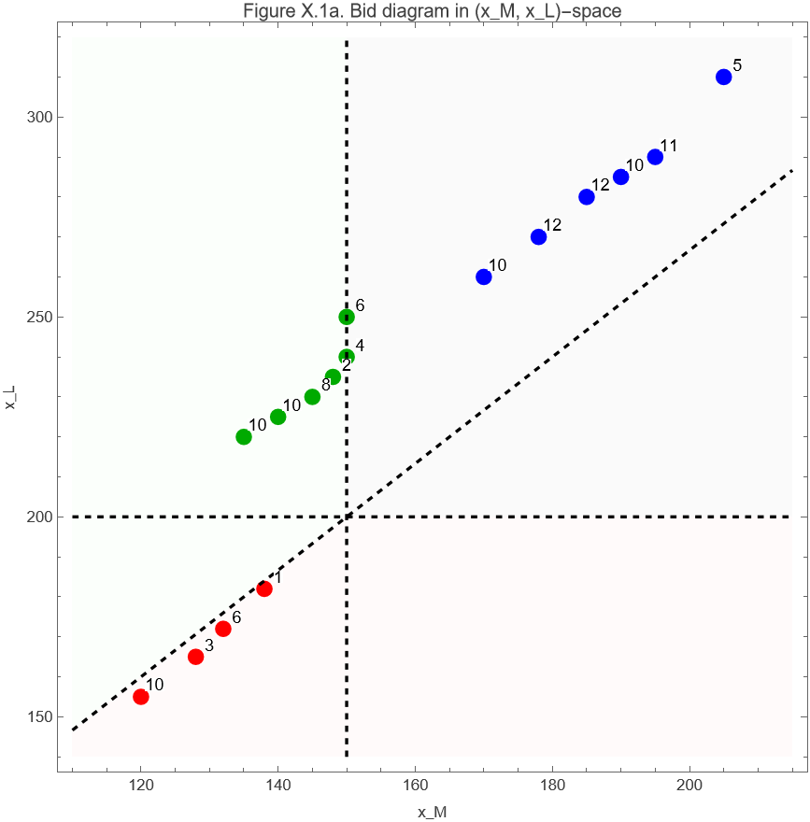
Summing across tranches this then gives the following “demand” for the three different debt types, $B_{S}=60,B_{M}=40,B_{L}=20.$Note that this turns out to be exactly the structure of the original debt. This is pure coincidence and not by design, changing the bids above would change these ratios. Now, the DSA envelope was given as $\left(Q_{S},Q_{M},Q_{L})=(30,30,20\right)$, which then implies per-unit payouts as follows, $q_{S}=\frac{30}{60}=0.5,q_{M}=\frac{30}{40}=0.75,q_{L}=\frac{20}{20}=1.0.$ In other words this would necessitate a haircut of 50% on short term debt, 25% on medium term debt and 0% haircut on long term debt.
Creditor-level outcomes
Note that the above implies that individual creditors will receive different haircuts. Table A1.4 details the results for each creditor showing how much new debt they would be awarded and the aggregate nominal haircut they would suffer. Creditors that are relatively more willing to accept longer maturities will receive more long-term debt and will then obtain a smaller face-value haircut. Creditors who are more willing to hold the longer-dated instrument contribute relatively more through maturity extension and relatively less through nominal reduction, while more impatient creditors receive more of the short bond and therefore a larger haircut. Applying the same present value haircut with a fixed interest rate would approximate this result but the PMA allows for different individual discount rates. It would only be by chance that all creditors would agree on the same discount rate. The PMA could be used to reveal what those individual discount rates are. In a more general setting with different types of debt with other characteristics, the PMA can also incorporate creditors’ valuations of those alternative features.

Table A1.4. Creditor outcomes
Creditor | Legacy face value | Budget to S/M/L | New short | New medium | New long | Total new face value | Haircut
C1 | 30 | 10 / 10 / 10 | 5.0 | 7.5 | 10.0 | 22.5 | 25.0%
C2 | 25 | 12 / 10 / 3 | 6.0 | 7.5 | 3.0 | 16.5 | 34.0%
C3 | 20 | 12 / 8 / 0 | 6.0 | 6.0 | 0.0 | 12.0 | 40.0%
C4 | 18 | 10 / 2 / 6 | 5.0 | 1.5 | 6.0 | 12.5 | 30.6%
C5 | 15 | 11 / 4 / 0 | 5.5 | 3.0 | 0.0 | 8.5 | 43.3%
C6 | 12 | 5 / 6 / 1 | 2.5 | 4.5 | 1.0 | 8.0 | 33.3%

Graphical representation of the PMA’s “fixed point”
As discussed, in this example, the PMA algorithm considers all the possible price (or compensation) ratios between medium-term and short-term debt, and between long term and short-term debt. It then considers, for each compensation ratio, which tranche-bids would be assigned to which type of debt. This then results in what we have referred to as the demand for short, medium and long-term debt. In our numerical example, the required demand consistent with the results of the DSA is given by, $\left(B_{S},B_{M},B_{L})=(60,40,20\right)$. In fact, this demand might result from several combinations of the price ratios. This is due to the fact that the bids are discrete and are not continuous functions. It might then be possible to alter the compensation ratio somewhat and yet the pattern of demand across the different debt types remains the same. Figure A1.2 illustrates the region of compensation ratios which results in the required pattern of demand. However, the DSA gives a very specific set of quantities and there is only one pair of compensation ratios which is fully consistent with those quantities and that is when the pair $\left(R_{M} , R_{L}\right)$ = (150,200). This is then a point within that feasible region, as also illustrated in the Figure. The actual clearing point is the fixed point where the implied payout ratios equal the ratios implied by the tranche-bids that indicate creditors’ preferences over the different debt types. So at this point the allocation is consistent with creditors’ preferences in the sense that each creditor would prefer the allocation received, compared to any other creditor’s allocation, and the DSA quantities are met.

Figure A1.2 Graphical Representation of the PMA Fixed Point
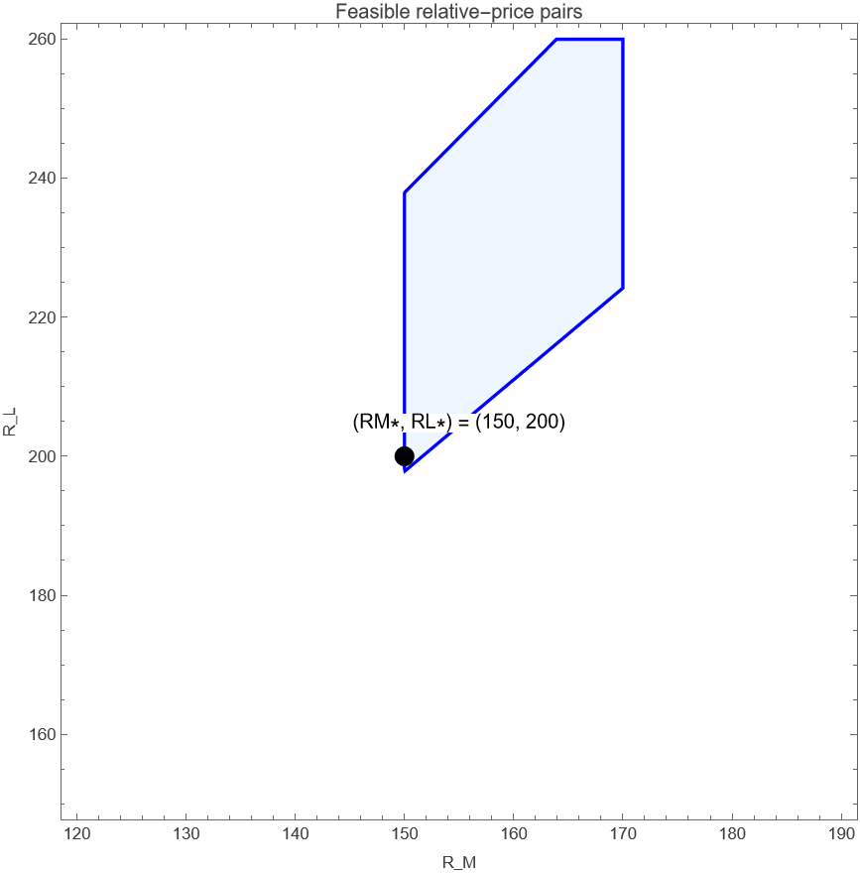
Discussion
This relatively simple example shows the DSA in action. The example has only 3 types of debt differentiated by maturity. In this case creditors prefer shorter to longer term debt but the strength of preferences vary. The PMA then allows creditors to express their preferences through a set of bids and the resulting restructuring is efficient in the sense that creditors would prefer their particular allocation rather than that received by any other creditor. The final allocation respects creditors’ wishes to generate demand curves for the different types of debt on offer, and also respects the results of a debt sustainability analysis which indicates how much debt the country can repay at each maturity.
While this example is relatively simple with just three types of debt, the mechanism is much more general. Many different types of debt could be included in the auction including floating and fixed instruments, instruments in different currencies, contingent instruments etc. The PMA would then elicit very valuable information on creditors’ preferences regarding these instruments which would then be extremely helpful to countries to decide which instruments to actually issue in a restructuring. The example here specified precisely the quantities of new debt to be issued in the restructuring so the PMA was used only to choose the prices and the allocation. In a more complex and general case, the country could provide ranges or potential combinations of aggregate debt that it would target to issue but leave the precise choice somewhat open and depending on the results of the auction. This would then be more like a standard auction that determined quantities and prices. Care would have to be taken to ensure that creditors had sufficient information regarding aggregate debt types to be issued in those cases where the value of one type of debt instrument might depend on the amount of debt issued in different categories.

Appendix 2: A Model of Debt Restructuring, Dilution and Comparability of Treatment
In this appendix, I detail a simple model of sovereign debt to illustrate the problem of debt dilution when there is comparable treatment of debt. I first set up a one period model in which a country issues one unit of (type A) debt to finance a project and where there is a possibility of default and restructuring. I then allow the country to issue additional (type B) debt after the first unit of debt is issued. I show that if a strict CoT rule is adopted for debt restructuring, then in general the country will have an incentive to issue additional debt and dilute existing creditors. In this model there is a deadweight cost of debt restructuring which rises as more debt is issued. The country is then worse off compared to a world where the country could commit to issuing no new debt. However, with an alternative restructuring rule, where debt is not treated equally, for example a rule that gives some seniority to the A debt then the incentive to issue the B debt may disappear and the country is made better off.
Setting the scene with one type of debt
The starting point is to consider a country that needs one unit of finance for an investment project. Let us suppose it raises this finance in a competitive market of risk neutral lenders. We will refer to this as A debt and the gross interest rate on this debt as rA (rA>r>0 where r is the riskless rate of interest). The project pays a return, y, and for simplicity I assume that the project either pays yL with probability p or yH with probability (1-p), and with yH>yL>0).
The timing is as follows. Type A debt is issued at the start of the period. At the end of the period, the project pays the return, the country decides whether to repay its debt and there is only consumption at the end of the period. I assume that the country is risk neutral. The risk-free gross interest rate is r and I will assume that the project is profitable investment in the sense that the expected return (p*yL+(1-p)yH) is greater than the riskless rate.
After the project pays out, the country should repay its debt plus interest of (rA). However, the country might choose to default. If the country defaults, I assume that there is a fixed default penalty,$∅$ (a deadweight cost), and the debt is restructured such that creditors receive a fraction of the project return λy where 0<λ<1.. Note that in this simple model we do not allow the country and the creditors to otherwise renegotiate the debt. As the creditors receive a fraction of the value of the project, this means that as the return of the project increases, the incentive to default is reduced. I will work with parameter values such that in general there will be default if y=yL and repayment when y =yH. If there is no default, the country-welfare (net income) is as follows:
$$W^{ND}=y-rA$$
While if there is default then welfare would be,
$$W^{D}=y-∅-λy$$
Assuming the investors in the country’s debt are risk neutral and competitive, and that there is indeed default at y=yL and repayment at y=yH, then the expected payment on the debt must equal the risk-free rate of interest:
$$r =rA\left(1-p\right)yH+p*λ*yL$$
Solving for rA yields::
$rA=\frac{r-p*yL}{1-p}$ Equation (1)
Welfare is then given by:
$W^{A} =\left(yH-rA\right)\left(1-p\right)+p*((1-λ)*yL-∅)$ Equation 2
Considering yL, yH,r, $∅$, λ and p as parameters, these two equations determine the interest rate on the country’s debt (rA) and country welfare (WA).
Introducing two types of debt and Comparable Treatment
However, suppose now that the country, having issued one unit of type A debt at the interest rate rA to finance the project under consideration, may issue B units of type B debt at rB. The country may invest the proceeds of that debt at the riskless rate of interest, r, and consume the proceeds at the end of the period. However, the country now has more debt to repay. As there are now two types of debt (A and B debt) it is critical to discuss what happens if the country decides to default and restructure the debt.
Assume that the country can either repay both types of debt, or default on both types of debt, it cannot selectively default on just one type of debt. In the case of default, assume that the country restructures and this results as before in a payment of λy to creditors. The idea is that this is the total creditors can extract from the borrower in default.
Consider the case where type A and type B debt are treated strictly in comparable fashion in the restructuring, or in other words both types of creditors receive the same payment per unit of debt. This means that A creditors, as a whole, would receive λ*yL/(1+B) while B creditors as a whole would receive λ*yL*B/(1+B) and both types of creditors would receive λ*yL/(1+dB) per unit of debt, where again we are assuming that default occurs only if y=yL. In that sense the haircut on the debt is the same for both groups and they are indeed treated “comparably”.
We also now assume that the country must pay the fixed default penalty $∅$ on each type of debt so the total deadweight cost is 2*$∅$. The idea here is that with more debt, and more types of debt, the restructuring will be more costly. An alternative would be to make the deadweight cost a continuous function of B, this assumption would complicate the algebra considerably and is not necessary to make the main points in the paper. The net income of the country if it does not default is as follows,
$$W^{AB,ND}=yH+B*r-rA-B*rB$$
And the welfare of the country given default would be,
$$W^{AB,D}=yL+B*r-λ*yL-2∅$$
The interest rate rB is determined to ensure that B creditors are compensated for the risk they are taking. The interest rate rB is then given implicitly by the following equation,
$r=rB*\left(1-p\right)+\frac{p*λ*yL}{(1+B)}$ Equation 3
An interesting question is whether the A creditors anticipate the issuance of the B debt. If not, then rA is determined with B=0, as we had before. However, this would not constitute a rational dynamic equilibrium. Here we take the opposite approach. Let’s assume that the A creditors do expect dilution. If this is the case, then rA must be such to satisfy a very similar equation:
$r=rA*\left(1-p\right)+\frac{p*λ*yL}{(1+B)}$
where B is the equilibrium expected B. Country welfare is given by:
$W^{AB}=\left(1-p\right)\left(yH+B*r-rA-B*rB\right)+p(B*r+(1-λ)*yL-2∅$) Equation 4
At this point it is important to recollect the timing of the model. Consider the moment where the A debt is already issued, and so rA is already determined, and the country is deciding how much B debt to issue. To decide if the country would issue B debt consider how welfare depends on B issuance. Differentiating welfare with respect to B, we find that:
$\frac{dW^{AB}}{dB}=r-\left(1-p\right)(rB+B\frac{drB}{dB}$)
where drB/dB can be found by differentiating the pricing equation - Equation 3. After some manipulation, it turns out that the marginal increase in welfare for a small change in B is given by,
$\frac{dW^{AB}}{dB}=\frac{p*λ*yL}{{(1+B)}^{2}}>0$ Equation 4
As can be seen, welfare is strictly increasing in B, assuming there is some positive probability of default (p>0), and the B creditors obtain a positive payment in default (λ*yL>0). The upshot is that the country has an incentive to issue as much B debt as is feasible.
What is the maximum amount of B debt that can issued? We have assumed throughout that there is repayment if y=yH and default at y=yL. But if the issuance of B debt is very large then at some point there would also be default at y=yH. The maximum amount of B debt issuance is given by the boundary condition where the country is indifferent between repayment and default when y=yH, this is given by:
$$yH+B*r-rA-B*rB=yH+B*r-λ*yH-2∅$$
Or in other words,
$${rA+rB\left(B\right)*B}_{}=λ*yH+2∅$$
This implies,
$rB=\frac{λ*yH+2∅-rA}{B}$ Equation 5
Note that at the B that satisfies this equation, the country is indifferent to repaying or defaulting. We will assume that the country would indeed repay. We can now solve Equation 5 and Equation 3 for B. An easy way to proceed is to eliminate rB from Equation 3 using this boundary condition, this then gives:
$$r=\left(1-p\right)*\frac{λ*yH+2∅-rA}{B}+\frac{p*λ*yL}{(1+B)}$$
Solving this Equation for B then gives,
$$B^{*}=\frac{(1-p)(λ*yH+2∅)+p*λ*yL}{r}-1$$
Note that as the A and B creditors face the same default probability and are paid the same, per unit of debt, in default then rA = rB in equilibrium, as the A creditors anticipate their dilution. Having solved for B, it is then possible to express country welfare as a function of the underlying parameters of the model,

$W^{AB}=\left(1-p\right)\left(yH+B^{*}r-\left(λ*yH+2∅\right)\right)+p(\left(1-λ\right)yL+B^{*}r-2∅)$ Equation 7
After some algebra, it can be shown that the difference between welfare if there is only A debt and welfare given dilution (such that B=BMax), is equal to p*$∅$. In other words,
$W^{A}-W^{AB}=p∅$ Equation 8
This can be interpreted as the cost to the country, if it cannot commit to not issuing new debt. If such a commitment is not possible then, after the type A debt is issued, the incentive is to issue B debt until the boundary condition is met, even though it turns out that this reduces welfare compared to the case of no B debt. It is an example of a time-consistency problem.
This is the case of strict comparability of treatment which translates, in this model, as full pari passu. Both the A creditors and the B creditors receive the same haircut on debt that is restructured, they face the same default probability and hence in equilibrium the interest rate the A and B creditors demand is the same.
At another extreme, suppose the A creditors are senior in the sense that in the case of default they are paid first, from whatever can be extracted from the borrower in the restructuring, up to the value of their claim. Only if there are additional resources would the B creditors receive anything in default.
In this case, if the country issued B debt it would not affect the payments to A creditors at all. If B debt is issued, A creditors are not diluted. The incentive for the country to dilute is then eliminated. The equilibrium of such a model would then be for the country to issue no B debt, even if the country could not commit to not issue that debt. Country welfare would be higher and equal to the case treated before with only A debt.
Intermediate cases are also possible depending on the restructuring regime. Suppose for example, following Chaterjee and Eyigungor (2015), a fraction, α, of the A debt is treated as senior while the remainder (1- α) is treated as pari passu. In this, “Partial Comparability of Treatment” case, the solution follows exactly the same steps as above.
The incentive to issue B debt, in this case, is provided by the following equation:
$\frac{dW^{AB}}{dB}=\frac{p(1-α)(λ*yL-α*rA)}{{((1-α)+B)}^{2}}$ Equation 9
Note that this remains positive for non-negative B., so long as $λ*yL>α*rA$. In other words so long as the total repayment to creditors in default is greater than the amount repaid to the A creditors (α*rA), then there is an incentive to issue B debt.
Let’s assume that this is the case for now. In this case the country will, once again, issue as much B debt as is feasible. Interestingly the boundary condition does not change. Altering the fraction, α, simply changes how the total amount paid in default is shared between the type A and type B creditors. If the country issues the maximum amount of B debt then B debt issuance is given by,
$$B^{*}=\frac{\left(1-p\right)(λ*yH+2∅)+p*λ*yL}{r}-1$$
Moreover, welfare would also remain unchanged. Assuming B debt issuance is at the maximum feasible amount, changing α shifts repayments between creditors (the larger the fraction of type A debt that is considered senior, then the lower rA and the higher rB) but does not alter the total payment to creditors and hence does not alter country welfare.
However, as α rises (and A creditors are made more senior) then the incentives to dilute change. In particular, at some point $λ*yL=α*rA.$ At that point, there is nothing to pay B creditors at all and the incentives for dilution disappear. There will then be a switch in regime to the case of only A debt as considered above.
Consider a numerical example of this model in practice. Suppose yL=1, yH=4, p=0.1 and r=1.05, λ=0.5 and ∅=0.2. The project is highly profitable in the sense that the expected return is much greater than the riskless rate of interest, the default probability is 10% and on default creditors can extract 50% of the project return and there is a deadweight cost of 0.2 which double to 0.4 if there is both type A and type B debt. Under these parameter values in the model with strict comparability of treatment (α =0), there would be an incentive for the country to issue B debt to the maximum feasible amount which would be 1.1 units of debt, rA=rB=1.14 and welfare (the expected net income to the country) would be 2.61. Given these results the country would default at yL and repay at yH as assumed.
If α is increased then initially the interest rate on type A debt (rA) falls while the interest rate on type B debt (rB) rises. The amount of B debt issued remains constant as does welfare, this simply shuffles repayment from the B creditors to the A creditors. However, the incentive to issue B debt declines (dW/dB falls). When α=0.45 the incentive is just eliminated. At this point, the proportion of A debt that is senior is just large enough such that, on default, there is nothing left to pay the B creditors, nor the junior part of the A debt. As the country now does not have an incentive to issue type B debt (and the A creditors anticipate that this will be the case), we revert to the regime with only A debt. The interest rate on type A debt (rA) falls and welfare increases. These results are illustrated in the graphs below.
Figure A2.1 plots the interest rate rA in the different regimes and in the selected equilibrium. If α is low then the country issues B debt to the maximum feasible amount. In the strict comparability case, rA=1.14 but declines as the seniority of the A debt rises. When α hit the value 0.45 the incentive to issue B debt vanishes and A debt is now priced expecting no debt dilution. In this example, rA=1.15 in this case.
Figure A2.1: The Interest Rate on Type A Debt for Different Levels of Seniority (α)
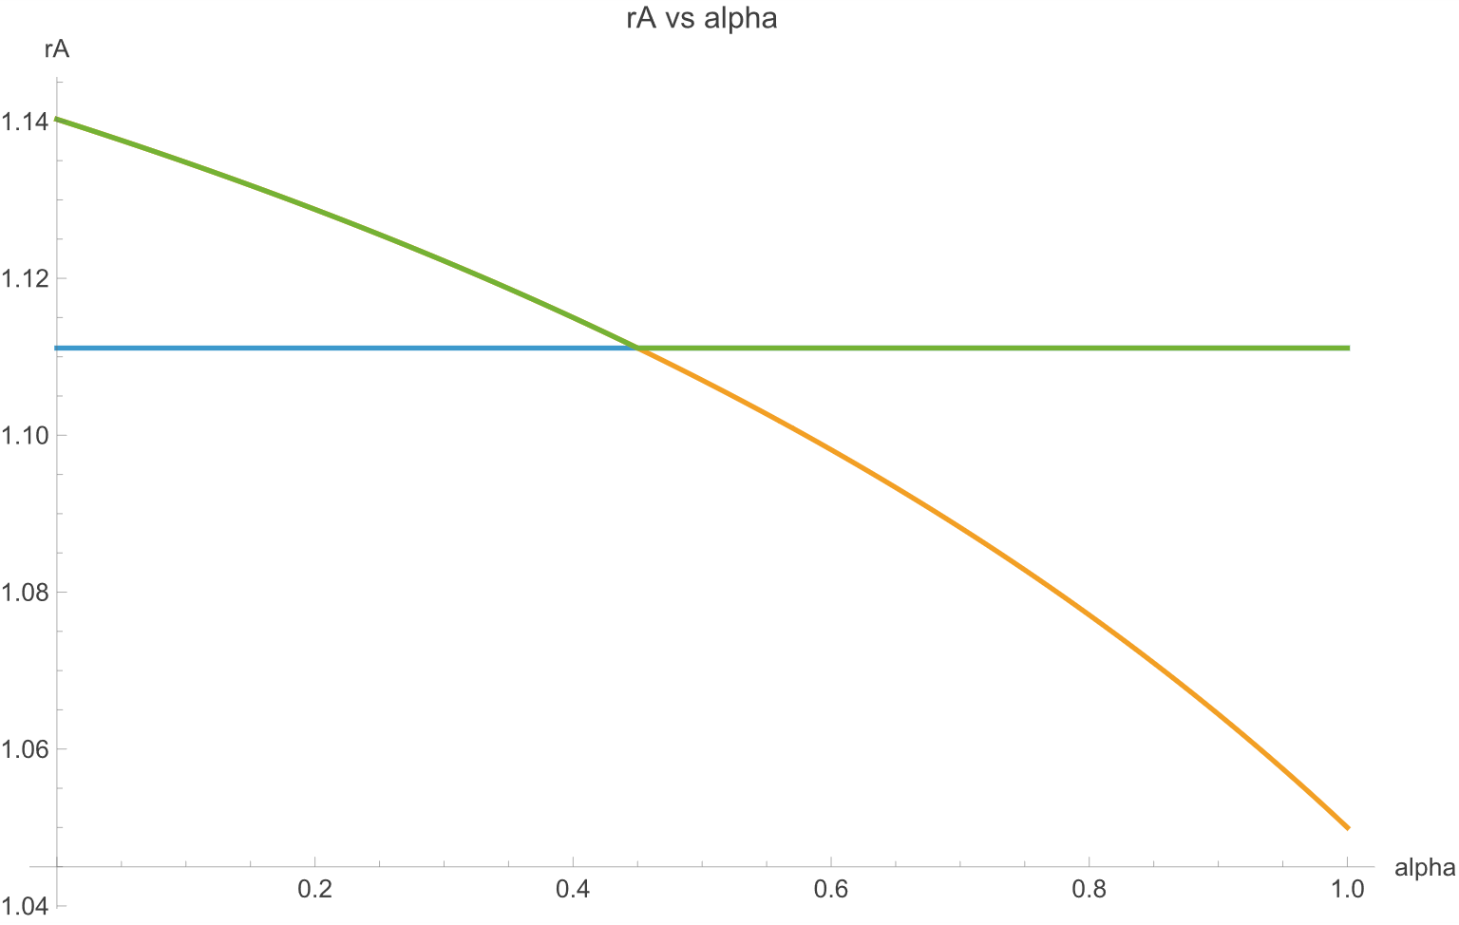
Figure 2 plots country welfare against the degree of seniority of A debt (α). In the case of strict comparability of treatment, country welfare is low as the country issues B debt to the maximum feasible amount and the A creditors, anticipating this, charge a high interest rate. If the fraction of A debt considered senior rises, then initially welfare does not change, this simply shifts repayment from the B to the A creditors (rA falls and rB rises). However, when α≥0.45, then the incentive to issue B debt disappears the regime switches to only A debt being present. In this scenario welfare jumps higher. The difference in welfare is the cost of the debt dilution given that the country cannot commit to not issuing new debt.
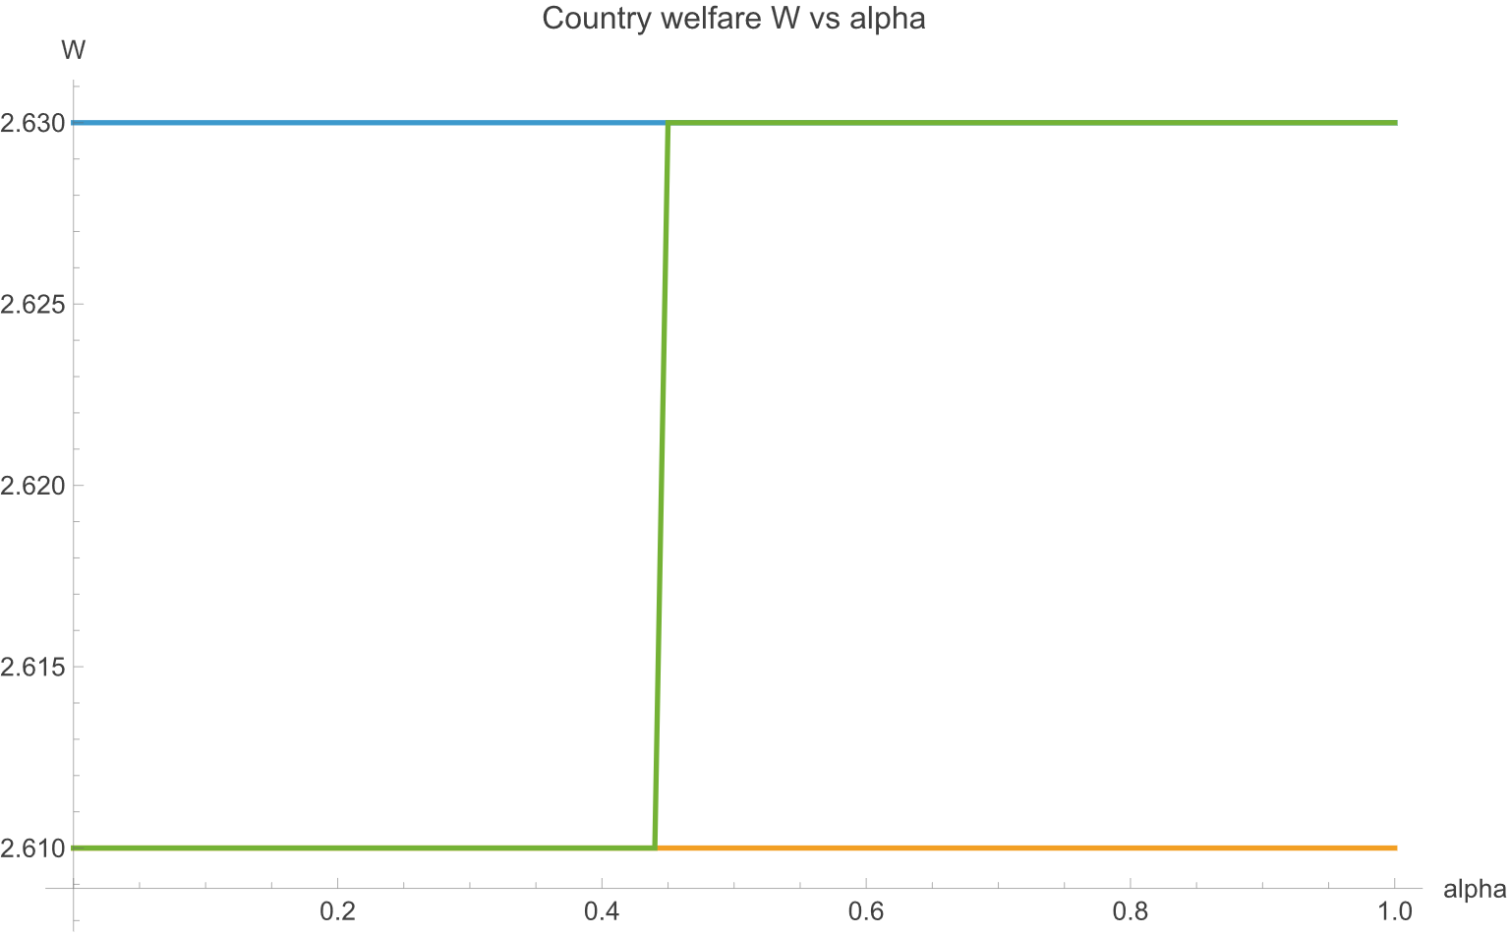
This analysis shows how a strict rule of comparable treatment would promote costly debt dilution while, a seniority structure, if it could be enforced, might eliminate those costs. The question is then how such a seniority structure might be enforced.

See IMF (2025b).
See IMF’s (2025a).
See for example Lazard (2022) and Rivetti (2022).
IDA is the International Development Association, part of the World Bank Group.
See for example Weiss (2012).
See Paris Club (2024)
The standard dynamic stochastic sovereign debt model such as Arellano (2008) typically finds it hard to explain actual debt levels, debt levels should be considerably lower.
Bolton and Jeanne (2009) argues that widely held debt may be more difficult to restructure, and hence may be, de facto, more senior. They suggest countries may be tempted to issue such debt effectively diluting other creditors.
An alternative is to assume that on default the borrower must pay a penalty which rises with the project return. This assumption, common in sovereign debt models, also implies that debt will be restructured when the country income level is low.
As country gross income is independent of whether the country repays or defaults, the boundary condition is when the cost of repaying is just equal to the cost of defaulting, when the project return is tH.
For example, short term debt might be considered as 1-2 years, medium debt 3-5 years and long term debt 5+ years.
The model could be generalized to a continuous distribution but in general this would make analytical results difficult to obtain and the model would likely have to be solved numerically.
This could be replaced by a bargaining framework. The critical aspect for the results regarding CoT to go through is that payments in default are limited in some fashion. To the extent that the payments in default are a function of the debt outstanding then the problem of debt dilution may be reduced.
This can be thought of as short-hand for some type of bargaining framework.
In this essentially one period model the discount rate plays no role.
If the deadweight cost is an increasing function of B then there could be an interior solution for the chosen quantity of B debt issued.
As can be readily appreciated, given anticipation rA=rB.
We apply these shares to the face value of the debt.

